SAMPOERNA UNIVERSITY
SUMMER PROGRAM
2019
INDUSTRIAL ENGINEERING
Object Oriented Modelling and Design

Name : Angeline Natasha Alicya Putri
Fani Fafas Tafia
Project : Modern Charity Box
Topic : Social-Religion
Concept : Online application- Modern Charity Box
Lecturer : Indra, S.Kom, M.T.I

- Related Work
Nowadays, there are many proposals that related with an online tool. As the time goes by, people prefer to do something in easier way. It makes us propose an innovation about something that familiar, charity box. This innovation aims to ease our life between spiritual and social. Technology cannot be ignored that has influence and change how people respond a problem. Therefore, we make a proposal of our innovation, online charity box. Previously, there is a proposal research that explain about online charity in terms of zakat, alms, or even wakaf. This proposal is planned by a student of industrial faculty of a university in Indonesia. It shows how to design a web for this online charity. This proposal needs another links that related in designing/ running a machine with server. We have searched many resources that connect with this project. First, the journal from another industrial faculty student from UniversitasMuhammadiyah Surakarta. This journal tells about how to make a system for infaq, wakaf, and alms in online way. It is our basic information regarding with this project. Second, the journal from an It faculty student from ITS. This journal tells about how to design/make a finance system with using PHP and MySQL. Third, the journal from AtikRusmayanti, Universitas Jakarta. This journal tells about finance managing system of a village. Fourth, the journal from UniversitasMuhammadiyahSukabumi. The journal tells about how to design a finance system for a corporation. Those fourth resources have connection with this project since the new project will include finance and online system. These resources will help us to improve our knowledge for building this new system.

- Outline
- Background
Charity box is already common in our daily life, especially for Muslim. Every time when Muslim goes to the Mosque, usually they will find out a charity box in front of or inside the mosque. We know that since the first time the charity box was created; it is always related to the cash money. It is because the purpose of creating this box is to collect the money for those who want to give alms.
Begins from the situation in our surrounding which can be categorized as a problem, we decide to use the charity box as an object in this project. The first reason is nowadays, especially in the big city, many people prefer to use a credit card instead of cash money. It can be understood because using a credit card is simpler than using cash money when doing a transaction. Indirectly, it also gives an impact to the charity box. Why? The busy people such as an employee often forgot to prepare cash for charity box.
The second reason is we found that, sometimes, the treasurer a bit difficult to manage the money. It is because cash money requires more time to calculate its amount. Also, an error is possible to happen when the treasurer is not careful enough when counting the money. It leads to inaccuracy of data that will be recorded which can also be categorized as a serious problem in the terms of accountancy.
The last reason is the increasing criminal cases, especially stealing charity box in mosque. Giving physical money attracts more eyes on charity box that will trigger bad people to steal and use it for their own business. Charity that primarily will be used as donation for needed people is gone. Indirectly, it will impact to people that want to give the alms. People will not put their money there again than the money is wasted in wrong way. They give the money is for goodness and praying. Never be thinking that it would make bad action, breaking their intention to pray. Again, security in conventional charity box is one of the considerations behind the launching of modern charity box.
This project is clearly stated if the final product will be a charity box that able to be used with a credit card and an online platform to display the data from the charity box machine, which has higher security system.
- Problem Formulation
- Conventional method requires more time to manage the data.
- Conventional charity box trigger more criminal action.
- Many busy people such officers do not have much time to drawn their money out before praying.
- Limitation
- Time
This project is expected to be done within nine months with the details below:
- Concept stage finishes in 3 months.
- Design stage finish in 2 months.
- Development stage finishes in 2 months.
- Production stage finishes in 2 months.
- Disposal stage will be considered when the product of this project needs an upgrade.
- Data
The data that will be used in this project is one of treasurers in our surrounding. We plan to use the data from “SalatJumat” in Sampoerna Academy last year.
- Application
The product of this project will use a web display. So, we will use Java to do a programming stage. Besides that, Java is easy to be used and more flexible than others.
- Budget
The budget in developing this project will come from the client. All the agreement about the budget will be written in the letter of agreement. It will be acknowledged by all of stakeholder in this project.
- Goal
Make an effective and efficient device that deals with:
- Process data/input faster than the usual tools.
- Guarantee for higher security system.
- Help people to be always give alms whenever, wherever, and in any conditions.
- Research Benefit
- Change the perception of people if only cash money that can be used for charity box.
- Decrease the amount of criminal action.
- Bring the charity box to the more modern style.

- Discussion
- Functional requirement
- Machine
- The user will be able to write the nominal of money.
- The machine will be able to detect the user’s card.
- The machine will be able to display a greeting after user transfer the money.
- The user will be able to log out immediately when they want, with the note the transfer process is not done yet.
- Server
The server will be able to display:
- Data number.
- Date, month, year, and transaction time.
- Account number.
- Incomes.
- Expenses.
- Notes.
- Balance.
- Non-functional requirement
- Product requirement
The server is private and can be only accessed by admin/treasurer.
Server can only be accessed via WEB.
User must have a card (credit, debit, ATM, etc.).
Offline data will be exported to Ms. Word.
Online data can be downloaded.
This application is non-paid application that can be upgraded.
- Organization Requirement
The file will be transferred from machine to the server corresponding with security encryption code.
- External Requirement
The information that can be read is account number of user.
- Business Process Current System
The money will be collected by using manual charity box.
The money will be counted once a week by the admin/treasurer.
The amount of money will be recorded in a file through manually or application.
- Business Process Proposed System
User will be able to do a transaction using card.
User will be able to write the nominal that they want to transfer.
User will tap their card to the scanner.
The money will be transferred to the bank.
The data of the transaction will be uploaded and will be saved by the server.

- Use case
- Use Case Diagram Money Collecting Stage
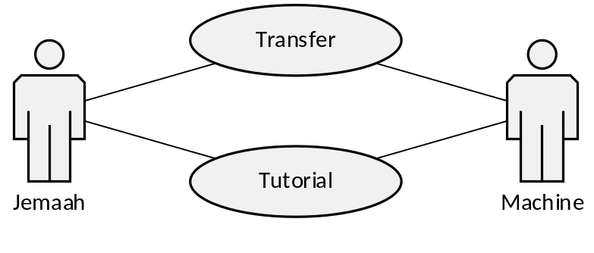
Figure 1 Use Case Diagram Money Collecting Stage
- Use Case Diagram Data Recording Stage
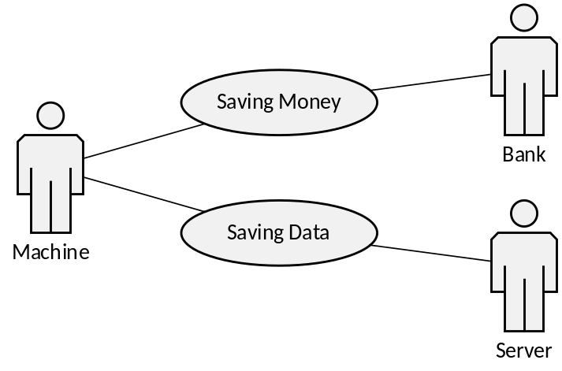

Figure 2 Use Case Diagram Data Recording Stage
- Use Case Diagram Data Managing Stage

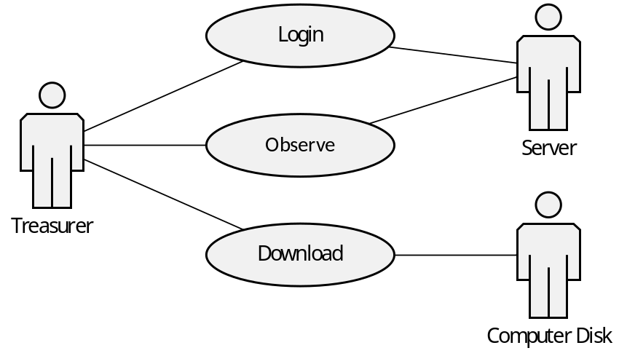
Figure 3 Use Case Diagram Data managing Stage

- Use Case Description
- Use Case Money Collecting Stage
- Use Case : Transfer
Actor : Jemaah, Machine
Purpose : Transfer the money
Description :
- Jemaah will write the nominal on the screen.
- Jemaah will tap their card onto the scanner.
- Machine will record the data.
- Use Case : Tutorial
Actor : Jemaah, Machine
Purpose : Display a tutorial of how to use the machine
Description :
- Jemaah will click the tutorial icon on the screen.
- Machine will display the tutorial about transfer the money through the screen.
- Use Case Data Recording Stage
- Use Case : Saving Money
Actor : Machine, Bank
Purpose : Saving the money via Bank
Description :
- Machine will send the data to the bank.
- Bank will record and save the money.
- Use Case : Saving Data
Actor : Machine, Server
Purpose : Archiving the data
Description :
- Machine will upload the data to the server.
- Server will keep the data.
- Use Case Data Managing Stage
- Use Case : Login
Actor : Treasurer, Server
Purpose : Login to the server
Description :
- Treasurer will login into the server.
- Treasurer will insert email address and password.
- Server will process the information.
- Server will display the data.
- Use Case : Observe Data
Actor : Treasurer, Server
Purpose : Treasurer will be able to manage the data flow
Description :
- Treasurer will look at the data flow in the server system.
- Treasurer will acknowledge if there is a problem.
- Server will display the data.
- Server will save the changes.
- Use Case : Download Data
Actor : Treasurer, Computer Disk
Purpose : Saving the offline document
Description :
- Treasurer will click the icon “download in the server”.
- Server will import the data into Ms. Word.
- The Computer disk will save the offline document.

7. Activity Diagram
- Activity Diagram Business Process Current System
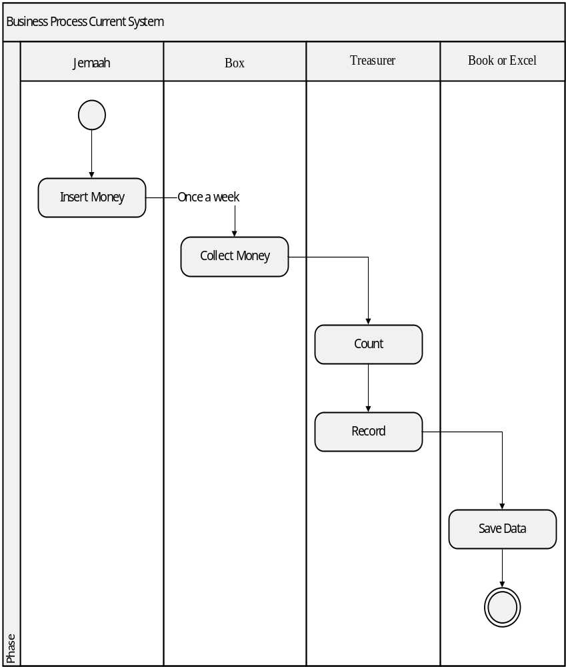
Figure 4 Activity Diagram Business Process Current System

- Activity Diagram Business Process Proposed System
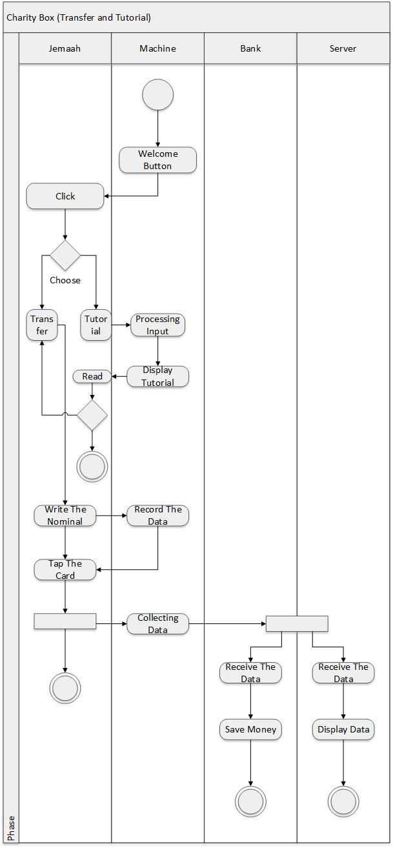
Figure 5 Activity Diagram Business Process Proposed System – Transfer and Tutorial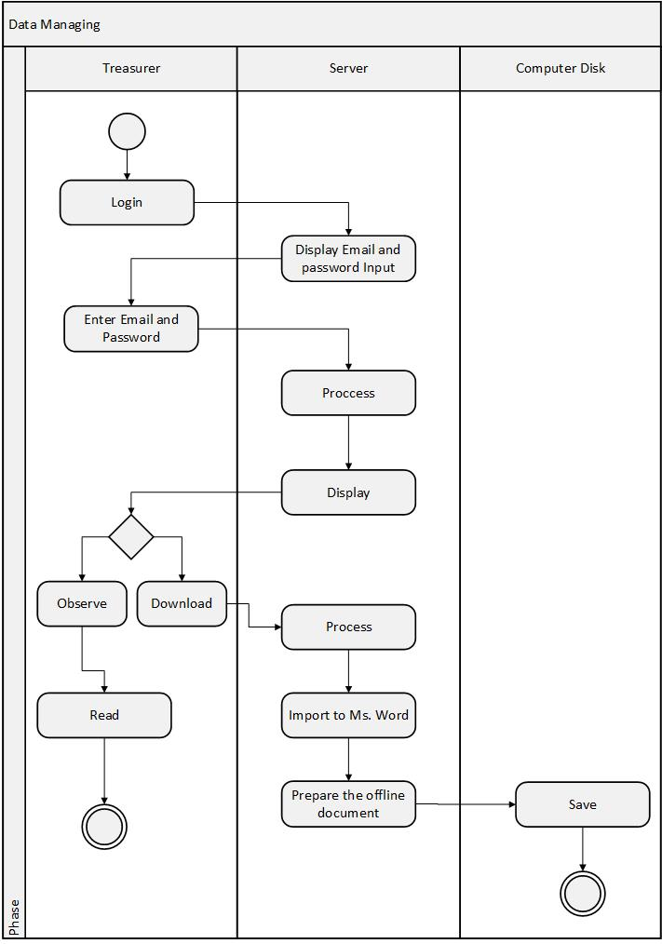

Figure 6 Activity Diagram Business Process Proposed System – Data Managing Stage

- Class Diagram
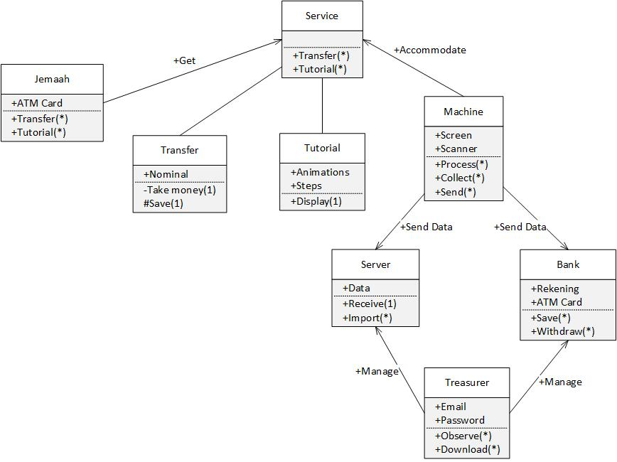

Figure 7 Class Diagram

Works Cited
Khoirun, Nio. “PerancanganSistemInformasiPenyaluran Dana Zakat, Infak, &SedekahBerbasisAplikasi Web MenggunakanCodeigniter Web Framework. 2016. http://eprints.ums.ac.id/47233/1/NASKAH%20PUBLIKASI%20-%20NIO%20KHOIRUN.pdf
Rusmayanti, Atik. “SistemInformasiPengelolaanKeuanganPadaDesaNgadirejan”. Vol 6 No 2. 2014. http://www.ijns.org/journal/index.php/speed/article/view/1321/1309
Isa, IndraGrihaTofik, and George PriHartawan. “PerancanganAplikasiKoperasiSimpanPinjamBerbasis Web (StudiKasusKoperasiMitraSetia)”. Vol 5. 2017. http://eprints.ummi.ac.id/60/3/Perancangan%20Aplikasi%20Koperasi%20Simpan%20Pinjam%20Berbasis%20Web%20%28Studi%20Kasus%20Koperasi%20Mitra%20Setia%29.pdf
Purnomo, EkoSigit, and FebriliyanSamopa. “PembuatanSistemInformasiRekonsiliasiKeuangan Negara Menggunakan PHP dan MySQL”. Vol 2 No 2. 2013. http://www.ejurnal.its.ac.id/index.php/teknik/article/view/4819/1089

Note:
This file will be continually updated during the process.

